**Experiment 8 - I**

**AIM**: Implement an application that uses GPS Location information

**MainActivity.java**

package com.example.gpslocation;

import androidx.appcompat.app.AppCompatActivity;

import android.Manifest;

import android.location.Location;

import android.location.LocationManager;

import android.os.Build;

import android.os.Bundle;

import android.widget.TextView;

public class MainActivity extends AppCompatActivity implements LocationListener {

LocationManager locationManager;

@Override

protected void onCreate(Bundle savedInstanceState) {

super.onCreate(savedInstanceState);

setContentView(R.layout.activity_main);

locationManager = (LocationManager) getSystemService(Context.LOCATION_SERVICE);

if (Build.VERSION.SDK_INT >= Build.VERSION_CODES.M) {

if (checkSelfPermission(Manifest.permission.ACCESS_FINE_LOCATION) != PackageManager.PERMISSION_GRANTED && checkSelfPermission(Manifest.permission.ACCESS_COARSE_LOCATION) != PackageManager.PERMISSION_GRANTED) {

ActivityCompat.requestPermissions(this, new String[]{Manifest.permission.ACCESS_FINE_LOCATION,}, 1); return;

}

}

locationManager.requestLocationUpdates(LocationManager.GPS_PROVIDER, 5000, 0, this);

}

@Override

public void onLocationChanged(Location location) {

((TextView) findViewById(R.id.tv_lat)).setText(String.valueOf(location.getLatitude()));

((TextView) findViewById(R.id.tv_long)).setText(String.valueOf(location.getLongitude()));

}

@Override

public void onStatusChanged(String provider, int status, Bundle extras) {}

@Override

public void onProviderEnabled(String provider) {}

@Override

public void onProviderDisabled(String provider) {}

}

**activity_main.xml**

<?xml version="1.0" encoding="utf-8"?>

<LinearLayout xmlns:android="http://schemas.android.com/apk/res/android"

xmlns:tools="http://schemas.android.com/tools"

android:layout_width="match_parent"

android:layout_height="match_parent"

android:orientation="vertical"

tools:context=".MainActivity">

<LinearLayout

android:layout_width="match_parent"

android:layout_height="wrap_content">

<TextView

android:layout_height="wrap_content"

style="@style/TitleTextView"

android:text="Latitude" />

<TextView

android:layout_height="wrap_content"

style="@style/TitleTextView"

android:text="Longitude" />

</LinearLayout>

<LinearLayout

android:layout_width="match_parent"

android:layout_height="wrap_content">

<TextView

android:id="@+id/tv_lat"

style="@style/ResultTextView"

android:layout_height="wrap_content"

android:text="Lat" />

<TextView

android:id="@+id/tv_long"

android:layout_height="wrap_content"

style="@style/ResultTextView"

android:text="Lon" />

</LinearLayout>

</LinearLayout>

**Output**

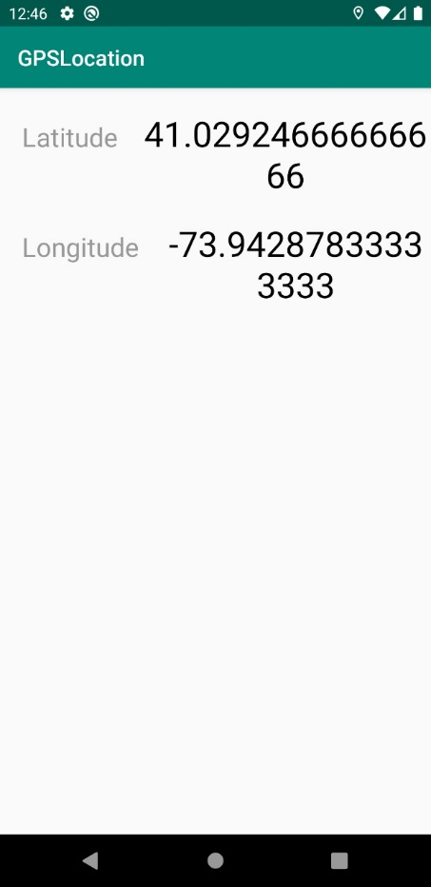

**Experiment 9**

**AIM**: Implement an application that that creates an alert upon receiving a message

**MainActivity.java**

package com.example.notification;

import androidx.appcompat.app.AppCompatActivity;

import androidx.core.app.NotificationCompat;

import android.app.NotificationChannel;

import android.app.NotificationManager;

import android.app.PendingIntent;

import android.content.Intent;

import android.graphics.Color;

import android.os.Bundle;

import android.view.View;

import android.widget.EditText;

import android.widget.Toast;

public class MainActivity extends AppCompatActivity {

String CHANNEL_ID = "channel";

int notificationId = 0;

NotificationManager notificationManager;

@Override

protected void onCreate(Bundle savedInstanceState) {

super.onCreate(savedInstanceState);

setContentView(R.layout.activity_main);

notificationManager = (NotificationManager) MainActivity.this.getSystemService(NOTIFICATION_SERVICE);

createNotificationChannel();

}

public void createNotificationChannel() {

if (android.os.Build.VERSION.SDK_INT >= android.os.Build.VERSION_CODES.O) {

NotificationChannel notificationChannel = new NotificationChannel(CHANNEL_ID, "Simple Notification", NotificationManager.IMPORTANCE_HIGH);

notificationChannel.enableLights(true);

notificationChannel.setLightColor(Color.RED);

notificationChannel.enableVibration(true);

notificationChannel.setDescription("Notifies every 15 minutes");

notificationManager.createNotificationChannel(notificationChannel);

}

}

public void sendNotification(View view) {

String contentText = ((EditText) findViewById(R.id.et)).getText().toString();

if (contentText.isEmpty()) {

Toast.makeText(MainActivity.this, "Please enter some text!", Toast.LENGTH_LONG).show();

return;

}

Intent contentIntent = new Intent(MainActivity.this, MainActivity.class);

PendingIntent contentPendingIntent = PendingIntent.getActivity(this, notificationId, contentIntent, PendingIntent.FLAG_ONE_SHOT);

NotificationCompat.Builder builder = new NotificationCompat.Builder(MainActivity.this, CHANNEL_ID)

.setSmallIcon(R.drawable.ic_launcher_foreground)

.setContentTitle("Alert")

.setContentText(contentText)

.setContentIntent(contentPendingIntent)

.setPriority(NotificationCompat.PRIORITY_HIGH)

.setAutoCancel(true);

notificationManager.notify(notificationId, builder.build());

}

}

**activity_main.xml**

<?xml version="1.0" encoding="utf-8"?>

<RelativeLayout xmlns:android="http://schemas.android.com/apk/res/android"

xmlns:tools="http://schemas.android.com/tools"

android:layout_width="match_parent"

android:layout_height="match_parent"

tools:context=".MainActivity">

<EditText

android:id="@+id/et"

android:layout_width="match_parent"

android:layout_height="match_parent"

android:hint="Enter Alert Text"

android:textSize="32sp"/>

<Button

android:layout_width="match_parent"

android:layout_height="wrap_content"

android:onClick="sendNotification"

android:layout_alignParentBottom="true"

android:text="Send alert"

android:background="#456"

android:textSize="32sp"

/>

</RelativeLayout>

**OUTPUT**

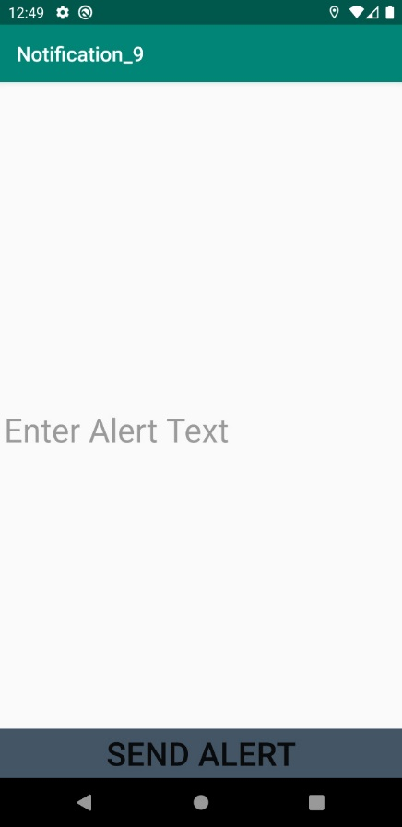 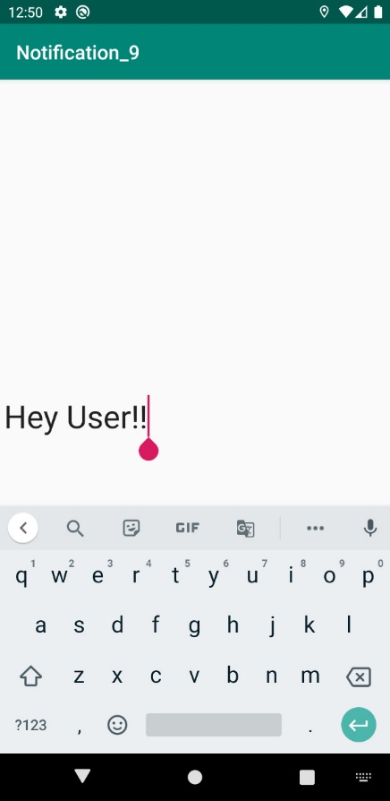

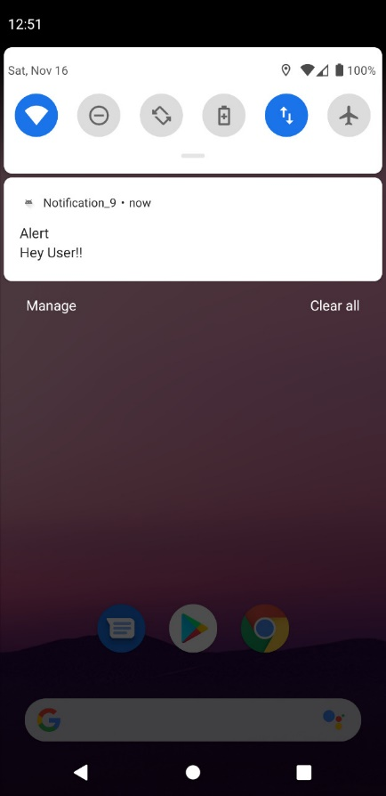

**Experiment 10**

**AIM**: Implement an application that creates an Alarm Clock

**MainActivity.java**

package com.example.lab10_alarm;

import android.app.AlarmManager;

import android.app.NotificationManager;

import android.app.PendingIntent;

import android.content.Intent;

import android.widget.TimePicker;

import android.widget.Toast;

import android.widget.ToggleButton;

import androidx.appcompat.app.AppCompatActivity;

import java.util.Calendar;

public class MainActivity extends AppCompatActivity {

TimePicker timePicker; PendingIntent pendingIntent; AlarmManager alarmManager;

ToggleButton toggleButton; NotificationManager mNotificationManager; Intent intent;

@Override

protected void onCreate(Bundle savedInstanceState) {

super.onCreate(savedInstanceState);

setContentView(R.layout.activity_main);

timePicker = findViewById(R.id.time_picker);

alarmManager = (AlarmManager) getSystemService(ALARM_SERVICE);

toggleButton = findViewById(R.id.toggle_button);

intent = new Intent(this, AlarmReceiver.class);

pendingIntent = PendingIntent.getBroadcast(MainActivity.this, 0, intent, 0);

alarmManager = (AlarmManager) getSystemService(ALARM_SERVICE);

timePicker.setOnTimeChangedListener(new TimePicker.OnTimeChangedListener() {

@Override

public void onTimeChanged(TimePicker view, int hourOfDay, int minute) { toggleButton.setChecked(false); }

});

toggleButton.setOnCheckedChangeListener(new CompoundButton.OnCheckedChangeListener() {

@Override

public void onCheckedChanged(CompoundButton compoundButton, boolean isChecked) {

String toastMessage;

long time;

if (isChecked) {

Calendar calendar = Calendar.getInstance();

calendar.set(Calendar.HOUR_OF_DAY, timePicker.getCurrentHour());

calendar.set(Calendar.MINUTE, timePicker.getCurrentMinute());

time=(calendar.getTimeInMillis()-(calendar.getTimeInMillis()%60000));

if(System.currentTimeMillis()>time) {

if (calendar.AM_PM == 0) { time = time + (1000*60*60*12); }

else { time = time + (1000*60*60*24); }

}

alarmManager.setRepeating(AlarmManager.RTC_WAKEUP, time, 10000, pendingIntent);

toastMessage = "Alarm On!";

} else {

alarmManager.cancel(pendingIntent);

toastMessage = "Alarm Off!";

}

Toast.makeText(MainActivity.this, toastMessage, Toast.LENGTH_SHORT).show();

} });

mNotificationManager = (NotificationManager) getSystemService(NOTIFICATION_SERVICE);

}}

**activity_main.xml**

<?xml version="1.0" encoding="utf-8"?>

<LinearLayout xmlns:android="http://schemas.android.com/apk/res/android" android:layout_width="match_parent" android:layout_height="match_parent" android:orientation="vertical">

<TimePicker android:id="@+id/time_picker" android:timePickerMode="clock" android:layout_width="wrap_content" android:layout_height="0dp" android:layout_weight="1"/>

<ToggleButton android:id="@+id/toggle_button" android:padding="20dp" android:textSize="48sp" android:layout_width="match_parent" android:layout_height="wrap_content" />

</LinearLayout>

**AlarmReceiver.java**

package com.example.lab10_alarm;

import android.app.NotificationManager;

import android.app.PendingIntent;

import android.content.BroadcastReceiver;

import android.content.Context;

import android.content.Intent;

import android.net.Uri;

import androidx.core.app.NotificationCompat;

public class AlarmReceiver extends BroadcastReceiver {

private NotificationManager mNotificationManager;

@Override

public void onReceive(Context context, Intent intent) {

mNotificationManager = (NotificationManager) context.getSystemService(Context.NOTIFICATION_SERVICE);

Uri alarmUri = RingtoneManager.getDefaultUri(RingtoneManager.TYPE_ALARM);

if (alarmUri == null) { alarmUri = RingtoneManager.getDefaultUri(RingtoneManager.TYPE_NOTIFICATION); }

Ringtone ringtone = RingtoneManager.getRingtone(context, alarmUri);

ringtone.play();

deliverNotification(context);

private void deliverNotification(Context context)

Intent contentIntent = new Intent(context, MainActivity.class);

PendingIntent contentPendingIntent = PendingIntent.getActivity (context, 0, contentIntent, PendingIntent.FLAG_UPDATE_CURRENT);

NotificationCompat.Builder builder = new NotificationCompat.Builder (context, "chaneel_id)

.setSmallIcon(R.drawable.ic_launcher_foreground).setContentTitle("Alarm")

.setContentText("Alarm On! Wake Up!").setContentIntent(contentPendingIntent)

.setPriority(NotificationCompat.PRIORITY_HIGH).setAutoCancel(true);

mNotificationManager.notify(NOTIFICATION_ID, builder.build());

}

}

**OUTPUT**

